- Which of the following statements concerning the elasticity of labour supply is true?
              - The total wage elasticity of supply tends to be positive and of low magnitude.
              - The income elasticity of supply tends to be positive and of low magnitude
              - The compensated elasticity of supply is close to zero
              - Overall workers tend to be highly responsive to wage changes
              - None of these above statements are true

- Suppose a worker is observed to be working but is forced to work fewer hours than she really wants to work. Which of the following statements is true?
              - The indifference curve that she is on is tangent to the budget line.
              - She is on an indifference curve which is lower than the one which is tangent to her budget line.
              - She is on an indifference curve which is higher than the one which is tangent to her budget line.
              - She is on an indifference curve which is lower than the one which passes through the point on the budget line corresponding to zero hours of work.
              - She is not on an indifference curve.

- The reservation wage is defined as:
              - the wage of the reservation clerk in the tourism industry.
              - the maximum wage that an employer is willing to pay a worker for a given job.
              - the minimum wage that an employee is willing to accept for a given job.
              - the equilibrium wage.
              - the wage rate at which zero hours of labour is supplied by the workers.

- Consider the situation of a worker who is ‘at the corner equilibrium' i.e., he or she is supplying zero hours of work and consuming 16 hours of leisure. In context of the income-leisure framework, which of the following statements is false?
              - The indifference curve is steeper than the budget line.
              - The marginal rate of substitution between income and leisure is greater than the wage rate in absolute value terms.
              - The indifference curve is flatter than the budget line.
              - The rate at which the worker is willing to exchange income for leisure is not equal to the market rate for the exchange of income for leisure.
              - Marginally, the worker values an hour of leisure more than she values an hour's worth of income.

- Which one of the following regarding to an individual's budget constraint is correct?
              - The slope of the budget constraint is determined by the market wage rate.
              - The level of non-labour income determines the intercept of the budget constraint.
              - The slope of the budget constraint is determined by the reservation wage rate
              - The slope of the budget constraint is equal to the marginal rate of substitution between income and leisure
              - The slope of the budget constraint is higher for a full-time worker than for a part-time worker.

- In the neo-classical model of labour supply, which of the following is always true?
              - If leisure is a normal good, a wage increase causes an increase in hours worked.
              - If leisure is a normal good, a wage increase causes a decrease in hours worked.
              - The income effect and the substitution effect work in the same direction.
              - The substitution effect causes the worker to work more hours if wages increase.
              - None of these options

- For a worker who is deciding how many hours of labour to supply, all of the following are true except that:
              - The marginal rate of substitution between income and leisure is equal to the wage rate.
              - The rate at which she is willing to exchange leisure for income equals the rate at which the market allows her to do it.
              - The slope of the budget line equals the slope of the indifference curve.
              - The income effect of a wage change equals the substitution effect.
              - The worker cannot increase total utility by working more or fewer hours.

- Which of the following statements most closely applies to the labour force participation decision?
              - It consists of the choice to allocate a portion of one's time to labour market activities as opposed to non-market activities.
              - It occurs when one accepts an employment position and is working.
              - It occurs when one is actively seeking work.
              - It includes paid and unpaid work.
              - It doesn't include unemployed workers.

- Which of the following statements applies to the unemployed population?
              - They are either unable to work, or are on strike.
              - They are jobless.
              - They are jobless but are actively seeking work.
              - They are working fewer hours than they would like to.
              - They are working but are underpaid.

- The portion of the population that is surveyed as potential labour force participants consists of:
              - the civilian non-institutional population.
              - the unemployed plus the employed population.
              - the entire civilian population that is 15 years of age or older.
              - Individuals who do hold jobs
              - the entire population of Canada.

- All of the following describe a demogrant except:
              - an income grant to a specific demographic group
              - the simplest income maintenance program
              - A grant whose amount varies with the worker's wage
              - a lump-sum transfer
              - That it shifts the potential income constraint vertically upward

- In the income-leisure framework, the impact of a demogrant payment involves which of the following?
              - Only a substitution effect
              - Only an income effect
              - Both a substitution and an income effect
              - A reservation wage effect
              - No impact on incentives at all

- What does the term negative refer to in a negative income tax scheme?
              - The individual does not have to pay income tax for any of his/her earnings.
              - The individual receives a subsidy or a credit rather than paying taxes for a certain number of hours worked.
              - The program does not involve any disincentives to working.
              - The program involves fewer disincentives to working than does a conventional welfare or social assistance program.
              - None of the choices are correct

- The difference between a conventional welfare program and a negative income tax program is that:
              - Recipients in the negative income tax program can receive labour market income without having all of their benefits clawed back
              - For the negative income tax program, the benefits received have to be repaid once the worker is working full time for wages.
              - Individuals have to be living below the poverty line in order to qualify for the negative income tax program.
              - The former type of program is transferred to the recipient by the government, while the latter is taxed away from the recipient by the government.
              - For the negative income tax program, the worker receives a wage supplement for each hour that he/she works.

- Which of the following situations is depicted in this figure? G refers to a government benefit payment.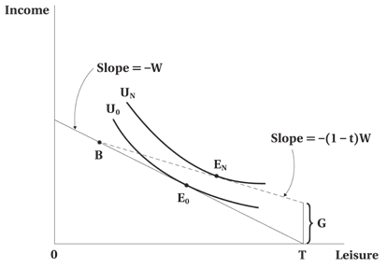
              - The absence of any income maintenance scheme
              - The Canadian Employment Insurance scheme
              - The wage subsidy scheme
              - The conventional welfare program
              - The negative income tax scheme

- What is the approximate rate at which lost earnings are replaced by Canada's unemployment insurance system?
              - 100% of all earnings up to a certain threshold, and 0% for wages above that level
              - 75% of all earnings
              - 55% of all earnings
              - 55% of all earnings up to a certain threshold, and 0% for wages above that level
              - 0% of earnings up to a certain threshold, and 55% for wages above that level

- The reason for which worker's disability insurance can potentially have adverse effects on work incentives is that:
              - the income that it provides enables one to reach a certain income level without any work obligation.
              - the opportunity cost of leisure increases.
              - the recipient is allowed to work as many hours as he/she can without losing any of the benefits.
              - the taxes that finance the benefits can have negative effects on labour demand.
              - All of the answer choices are correct.

- The Canadian Employment Insurance Program is best known for its generosity towards:
              - Long-term unemployed workers
              - Older unemployed workers
              - High-wage unemployed workers
              - Seasonally unemployed workers
              - No particular group of unemployed workers

- Which of the following statements concerning subsidies for child care expenses is true?
              - They change the slope of the budget line.
              - They reduce the fixed costs of working.
              - They discourage labour force participation.
              - They tend to increase the reservation wage of working.
              - They cause a strong substitution effect toward more working activity.

- Suppose that a worker says that due to a refundable tax benefit, it appears to her that working pays more than it used to, and so she wants to work longer hours. What type of effect is involved?
              - Only a substitution effect
              - Only an income effect
              - Both a substitution and an income effect
              - A reservation wage effect
              - No impact on incentives at all

- Assume that at the wage rate of $10 per hour, a firm is hiring 100 hours of labour per week. If the wage elasticity of demand is -1.2, how many hours of labour will the firm shed if the wage increases by $2 per hour?
              - 5 hours per week
              - 12 hours per week
              - 20 hours per week
              - 24 hours per week
              - 36 hours per week

- The primary reason why workers in the fast-food industry are paid less is that:
              - The demand for the product that they produce is quite elastic, making the demand for labour wage elastic.
              - It is easy to substitute capital for labour in the industry, making the demand for labour wage elastic.
              - Labour costs comprise a large share of the employer's expenses, making the demand for labour wage inelastic.
              - These workers collect economic rents.
              - These workers are seldom unionized.

- If the employer is a monopolist in the output market:
              - There is monopsony in the input market.
              - The demand for labour is less elastic than it would be if the firm operated in a competitive output market.
              - The demand for labour is less elastic than it would be if the firm operated in a competitive input market.
              - The firm's demand curve for labour is identical to the case where the firm is a competitor in the output market.
              - None of the above choices are correct.

- Suppose that the wage elasticity of labour demand is -0.55. Which of the following statements is true?
              - A $ 1 increase in wages corresponds to a 0.55 unit decrease in quantity demanded of labour
              - A $ 0.55 increase in wages corresponds to a 1 % decrease in quantity demanded of labour
              - A 0.55 % increase in wages corresponds to a 1 % decrease in quantity demanded of labour
              - A $ 1 increase in wages corresponds to a 0.55 % decrease in quantity demanded of labour
              - A 1 % increase in wages corresponds to a 0.55 % decrease in quantity demanded of labour

- Which of the following statements is false?
              - The quantity demanded for school teachers is equal to the quantity supplied in equilibrium.
              - The demand for school teachers is downward sloping because it is profitable for schools to hire more teachers when wages fall.
              - The demand for school teachers is likely to fall when the government decides to cut funding to schools.
              - The demand for school teachers is likely to be quite wage elastic.
              - The demand for school teachers is likely to rise when the government decides to cut funding to schools.

- For labour demand choices, the long run is defined as:
              - the time period over which all costs are fixed.
              - the period of time over which all inputs can vary.
              - the period of time over which fixed factors cannot vary.
              - the period of time over which variable factors can vary.
              - the period of time over which variable factors cannot vary.

- All of the following statements regarding the marginal product of labour are true except:
              - The firm will hire units of labour until it is equal to the going wage rate.
              - It intersects the average product of labour curve at the maximum point on that curve.
              - It is zero at the maximum value of total product.
              - It eventually diminishes in value because the capital stock is fixed.
              - It is the increment to total product obtained by hiring one more unit of a variable factor.

- In the short run, the demand for labour for a competitive firm is:
              - the marginal product of labour curve.
              - the same as the total demand curve for labour.
              - the downward sloping portion of the value of the marginal product curve.
              - perfectly elastic at the market wage.
              - perfectly inelastic at the market wage.

- With respect to the labour demand choice in the long run, which of the following statements is false? MPP_{L} = marginal physical product of labour, MPP_{K} = marginal physical product of capital, w = wage, and r = rate of return on capital
              - MPP_{L}/MPP_{K} = w/r.
              - W = VMP_{L} and r = VMP_{K}.
              - VMP_{L}/VMP_{K} = w/r.
              - The equilibrium is situated at the point of tangency between the highest isoquant and the isocost curve
              - Profits are maximized.

- With respect to labour demand choice in the long run, which of the following statements is false? MPP_{L} = marginal physical product of labour, MPP_{K} = marginal physical product of capital, w = wage, and r = rate of return on capital
              - The rate at which capital can be substituted for labour in the technology of production is equal to the rate at which capital and labour can be exchanged in the market
              - MPP_{L}/MPP_{K} = w/r.
              - MPP_{L} * r = MPP_{K}* w
              - The profit made per worker is maximized
              - The marginal rate of technical substitution is equal to the ratio of factor prices

- The scale effect of a wage change implies that:
              - Firms substitute toward the input that has become relatively cheaper.
              - The wage elasticity of demand is inelastic
              - The demand for labour may be upward sloping if labour is an inferior input.
              - The firm reduces its output in response to the wage increase.
              - In order to increase output, a firm will use more labour even if the wage increases.

- The slope of an isoquant reflects:
              - the marginal cost of labour.
              - the wage elasticity of the demand for labour.
              - the marginal rate of technical substitution between inputs.
              - the marginal productivity of capital.
              - the marginal productivity of labour.

- Along an isocost curve, which of the following remains constant?
              - The market prices of inputs
              - The quantity of labour utilised
              - The quantity of capital utilized
              - The level of production
              - The wage elasticity of demand for labour

- In the context of outsourcing, consider the case where domestic labour and foreign labour are complements. If there is an increase in the wage paid to domestic labour, then which of the following statements is true?
              - There will be a substitution effect and a scale effect away from domestic labour.
              - There will be a substitution effect and a scale effect towards domestic labour.
              - There will be a small substitution effect away from domestic labour, but the scale effect will work toward domestic labour.
              - There will be a small substitution effect toward domestic labour, but the scale effect will work in favour of domestic labour.
              - There will be no substitution effect but only scale effect.

- In order to obtain the scale effect of a wage change:
              - One traces the change of the quantity demanded of labour through a parallel shift in the isocost line.
              - One moves either up or down the labour demand curve.
              - One traces the change in the quantity demanded of labour by moving along an isoquant curve as the prices change.
              - One needs to first know the wage elasticity of demand for labour.
              - One traces the change in output as firms respond to it.

- Which of the following is correct regarding the elasticity of labour demand?
              - If capital and labour are easily substitutable, the derived demand for labour will be inelastic.
              - If the supply of substitute inputs is inelastic, the derived demand for labour will be inelastic.
              - If the product demand is elastic, the derived demand for labour will be inelastic.
              - If the share of the labour costs in total costs is large, the derived demand for labour will be inelastic.
              - None of the choices are correct.

- Which of the following is correct regarding the impact of globalization on the Canadian market?
              - Due to global competition, if there is a change in the product price, productivity of Canadian labour will decrease.
              - The labour demand in the Canadian market will decrease.
              - If Canadian labour and foreign labour are close substitutes, cheaper foreign labour will lead to scale effects, which may increase the demand for Canadian labour and foreign labour (holding other factors fixed)
              - If Canadian labour and foreign labour are complements, cheaper foreign labour will lead to scale effects, which may increase the demand for Canadian labour and foreign labour.
              - The labour demand in the Canadian market will increase.

SECTION BREAK. Answer all the part questions.
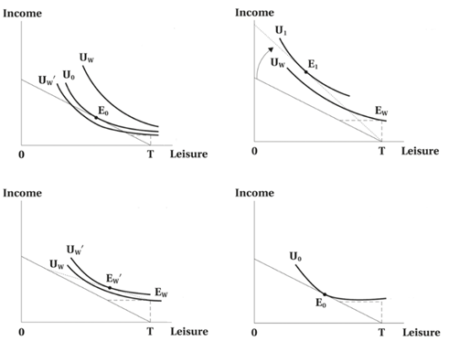

- The four diagrams depict various ways to affect the incentive structure that is inherent in welfare programs. Which one shows the impact of increasing the offered wage rate?
                - Top left
                - Top right
                - Bottom left
                - Bottom right

- The four diagrams depict various ways to affect the incentive structure that is inherent in welfare programs. Which one shows the impact of reducing the implicit tax rate?
                - Top left
                - Top right
                - bottom left
                - bottom right

- The four diagrams depict various ways to affect the incentive structure that is inherent in welfare programs. Which one shows the impact of changing preferences such that recipients value labour market activity more?
                - Top left
                - Top right
                - bottom left
                - bottom right

The following diagrams of budget constraints pertain to the next three questions. The vertical axis is Income and the horizontal axis is Leisure.
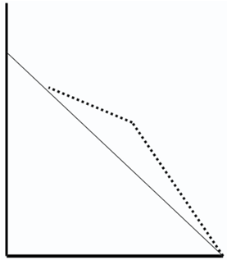 Figure a) 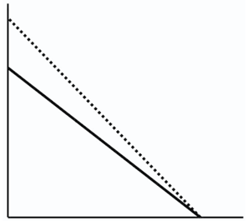Figure b)
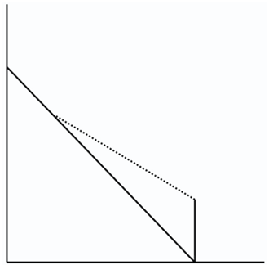Figure c) 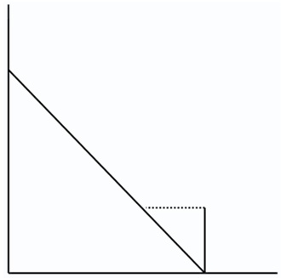 Figure d)

- Which of the diagrams of budget constraints above depicts the Earned Income Tax Credit program?
                - a)
                - b)
                - c)
                - d)

- Which of the diagrams of budget constraints above depicts the Wage Subsidy program?
                - a
                - b
                - c
                - d

- Which of the diagrams of budget constraints above depicts the Negative Income Tax program?
                - a
                - b
                - c
                - d

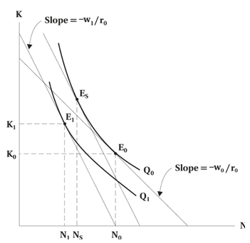
- Assume that the wage increases from W₀ to W₁, but the rate of interest remains at r₀. The substitution effect is given by:
                - N₀ to N_{S}
                - N₀ to N₁
                - N_{S} to N₁
                - K₀ to K₁
                - We cannot tell

- Assume that the wage increases from W₀ to W₁, but the rate of interest remains at r₀. The scale effect is given by:
                - N₀ to N_{S}
                - N₀ to N₁
                - N_{S} to N₁
                - K₀ to K₁
                - We cannot tell

